

DEPARTMENT OF BASIC SCIENCE AND HUMANITIES INSTITUTE OF ENGINEERING AND MANAGEMENT, KOLKATA

**“FILE MANAGEMENT SYSTEM”**

## Submitted by:-

**Name of the Student:** Shashank Parth Sinha

**Enrolment Number:** 12022002011045

**Registration Number: 221040110566**

**Section:** J

**Class Roll Number:** 17

**Stream:** Electrical Engineering (EE) **Subject:** Programming for Problem Solving **Subject Code:** ESC-103 (Pr)

Under the supervision of:-

**Prof. Swarnendu Ghosh**

**Academic Year: 2022-26**

(PROJECT REPORT SUBMITTED IN FULFILLMENT OF THE REQUIREMENTS FOR THE SECOND SEMESTER)



## CERTIFICATE OF RECOMMENDATION

We hereby recommend that the project prepared under our supervision by **Shashank Parth Sinha**, entitled **“File Management System”** be accepted in fulfillment of the requirements for the degree of fulfillment of the second semester.

Head of the Department Project Supervisor IEM, Kolkata Basic Science and Humanities

# Introduction:

This project is assigned to me for development of a File Management System with the help of basic C programming language.

The basic aim of the project is to create a file management system wherein we can create a file, edit it and delete the same.

# Variable Description:

The different variables used in this project are listed under:-

* 1. FILE *fp: a pointer to a file object, used to open and close files and write to them.

2. char filename[100]`: a character array used to store the name of the file entered by the user.

3. int choice: an integer variable used to store the user's menu choice..

# 3.Function Description:

The function (structures) used in this project is given as:-

* + 1. main(): the main function that runs the file management program.

# Programs:

*FileManager.c*

#include <stdio.h>

#include <stdlib.h>

int main()

{

FILE *fp;

char filename[100];

int choice;

printf("\n Name: Shashank Parth Sinha");

printf("Section : J");

printf("\n----------------------------");

printf("File Manager Program\n");

printf("-----------------------------\n");

while(1)

{

printf("\n1. Create a new file\n");

printf("2. Modify an existing file\n");

printf("3. Delete a file\n");

printf("4. Exit\n");

printf("\nEnter your choice: ");

scanf("%d", &choice);

switch(choice)

{

case 1:

printf("\nEnter the name of the file to create: ");

scanf("%s", filename);

fp = fopen(filename, "w");

if(fp == NULL)

{

printf("\nError creating file. Please try again.\n");

}

else

{

printf("\nFile created successfully.\n");

fclose(fp);

}

break;

case 2:

printf("\nEnter the name of the file to modify: ");

scanf("%s", filename);

fp = fopen(filename, "a");

if(fp == NULL)

{

printf("\nError opening file. Please try again.\n");

}

else

{

printf("\nEnter the text to append to the file: ");

char text[100];

scanf("%s", text);

fprintf(fp, "%s", text);

printf("\nText added successfully.\n");

fclose(fp);

}

break;

case 3:

printf("\nEnter the name of the file to delete: ");

scanf("%s", filename);

int status = remove(filename);

if(status == 0)

{

printf("\nFile deleted successfully.\n");

}

else

{

printf("\nError deleting file. Please try again.\n");

}

break;

case 4:

printf("\nExiting program.\n");

exit(0);

default:

printf("\nInvalid choice. Please try again.\n");

}

}

return 0;

}

# Outputs:

Sample outputs (screenshots) to demonstrate the functionalities in programs are listed below.

Creation of a file :

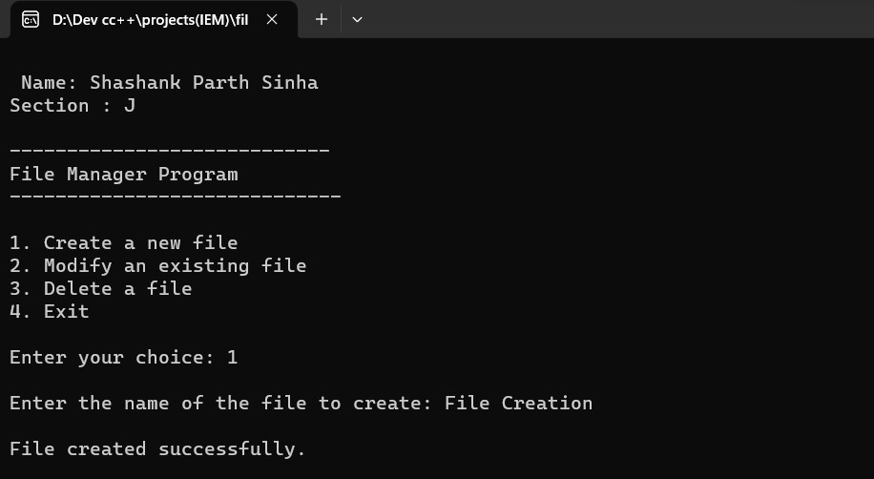

Modifying a file :

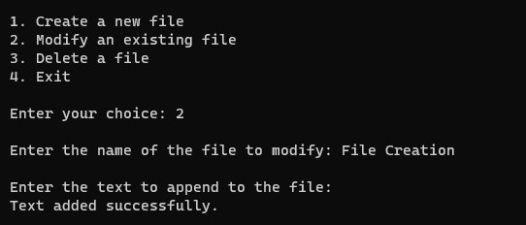

Deletion of a file :

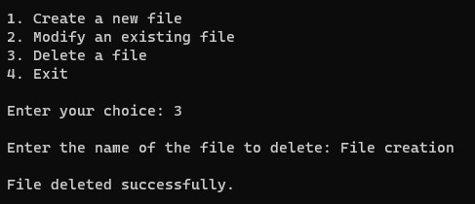

Exiting from the program :

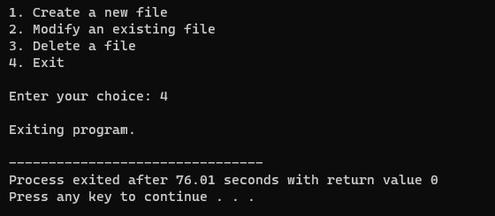

**THANK YOU!!**